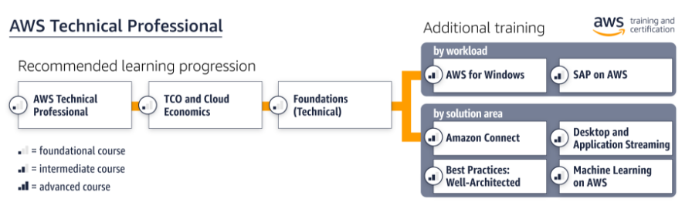

# Foundational Training

|  |  |  |  |
| --- | --- | --- | --- |
| Training | Type | Duration | Register |
| AWS Technical Professional | Digital | 6 hours | [Register for the digital course](https://partnercentral.awspartner.com/LmsSsoRedirect?RelayState=%2flearningobject%2fcurriculum%3fid%3d11276&src=path-tech-pro) |
| AWS TCO and Cloud Economics | Digital | 3 hours | [Register for the digital course](https://partnercentral.awspartner.com/LmsSsoRedirect?RelayState=%2flearningobject%2fcurriculum%3fid%3d10743&src=path-tech-pro) |
| AWS Solutions Training for Partners: Foundations (Technical) | Classroom | 1 day | [Find classroom training](https://partnercentral.awspartner.com/SiteLogin?startURL=%2FLmsSsoRedirect%3FRelayState%3D%252Ftraining%252Fschedule%253FcourseId%253D18078&src=path-tech-pro) |
| Free digital training |  |  | [Start learning for free at aws.training](https://www.aws.training/training?src=path-tech-pro) |

# Additional Workload Training

|  |  |  |  |
| --- | --- | --- | --- |
| Training | Type | Duration | Register |
| AWS Solutions Training for Partners: AWS for Windows (Technical) | Classroom  Digital | 1 day  3 hours | [Find classroom training](https://partnercentral.awspartner.com/LmsSsoRedirect?RelayState=%2ftraining%2fschedule%3fcourseId%3d12932&src=path-tech-pro)  [Register for the digital course](https://partnercentral.awspartner.com/LmsSsoRedirect?RelayState=%2flearningobject%2fcurriculum%3fid%3d13965&src=path-tech-pro) |
| AWS Solutions Training for Partners: SAP on AWS (Technical) | Classroom  Digital | 1 day  4 hours | [Find classroom training](https://partnercentral.awspartner.com/LmsSsoRedirect?RelayState=%2ftraining%2fschedule%3fcourseId%3d14639)  [Register for the digital course](https://partnercentral.awspartner.com/LmsSsoRedirect?RelayState=%2flearningobject%2fcurriculum%3fid%3d15730) |

# Additional Solutions Training

|  |  |  |  |
| --- | --- | --- | --- |
| Training | Type | Duration | Register |
| AWS Solutions Training for Partners: Amazon Connect (Technical) | Digital | 1.5 hours | [Register for the digital course](https://partnercentral.awspartner.com/LmsSsoRedirect?RelayState=%2flearningobject%2fcurriculum%3fid%3d14079&src=path-tech-pro) |
| AWS Solutions Training for Partners: Best Practices: Well-Architected | Digital | 2 hours | [Register for the digital course](https://partnercentral.awspartner.com/LmsSsoRedirect?RelayState=%2flearningobject%2fcurriculum%3fid%3d14875&src=path-tech-pro) |
| AWS Solutions Training for Partners: Desktop and Application Streaming (Technical) | Digital | 2 hours | [Register for the digital course](https://partnercentral.awspartner.com/LmsSsoRedirect?RelayState=%2flearningobject%2fcurriculum%3fid%3d18554&src=path-tech-pro) |
| AWS Solutions Training for Partners: Machine Learning on AWS (Technical) | Classroom  Digital | 1 day  4 hours | [Find classroom training](https://partnercentral.awspartner.com/LmsSsoRedirect?RelayState=%2ftraining%2fschedule%3fcourseId%3d21919&src=path-tech-pro)  [Register for the digital course](https://partnercentral.awspartner.com/LmsSsoRedirect?RelayState=%2flearningobject%2fcurriculum%3fid%3d22327&src=path-tech-pro) |